**Examination of an externally loaded leaking flange joint for leaking using finite element analysis**

**Chidhambara Ayyanar, Sam Gilbert, Michael Regan,** and **Bijoy Verghese**

**ABSTRACT**

Bolted flange joints heavily utilize gaskets to create a seal in pipelines. Not only do gaskets experience high operating pressures and external loads, but also elemental exposure affect the integrity of the gasket seal. When seal performance fails, alternative flange joints must be examined. This investigation explores the feasibility of replacing an existing spiral wound gasket on a flange joint with a ring type joint for high pressure pipelines.

**1.0 Introduction**

A leak in a flange joint was discovered in an offshore high pressure gas pipeline feeding an onshore facility. Investigation of the joint identified minor gas leakages in the joint’s spiral wound gasket (Figure 1), a component not recommended to be utilized under high pressures and high external loads. An additional root cause of the gas leakage was identified as soil settlement across the pipeline, resulting in a high differential external load on the flange joint. Although leakage risks were mitigated via reduction in gas operating pressure and the installation of a temporary clamp on the joint, a long-term solution was needed.

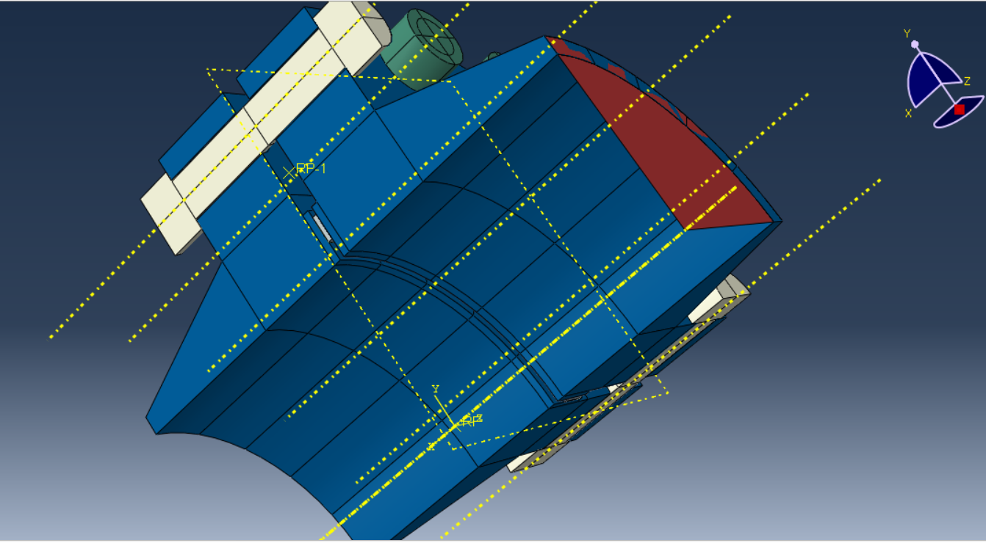

Figure 1: Model representation of existing joint and its spiral wound gasket

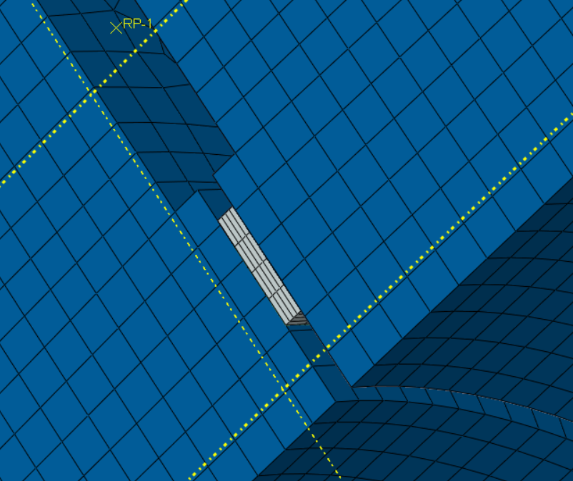

Figure 2: Close-up of model representation of existing spiral wound gasket

This investigation explores the feasibility of replacing the existing flange joint and its existing spiral wound gasket (Figure 2) with a ring type joint (Figure 3).

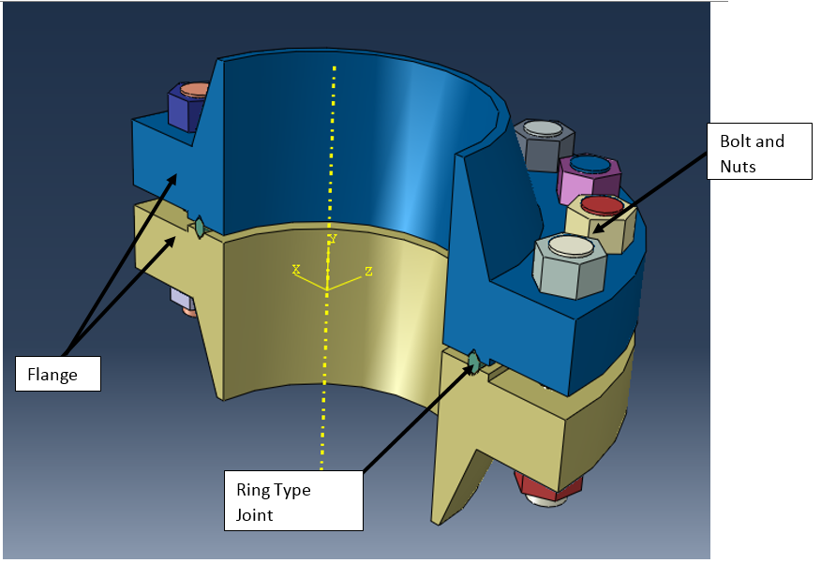

Figure 3: Proposed ring type flange joint

The pipeline runs over a hundred kilometers in length and is 12” in diameter. The minor gas leakage was observed at an operating pressure of 60 bar. Further reduction of the operating pressure to 40 bar initially indicated no further leakage, however during verification, gas leakage was still observed at 29.6 bar operating pressure.

**2.0 FE analysis**

This investigation performed two forms of analyses. The team coding their own solver using Matlab to determine XXXXX. The second solver utilized Abaqus. For both solvers, the team modeled a two dimension slice of one side of the proposed gasket of the ring type joint (RTF) and modeled the contact force as an equivalent pressure.

Total number of nodes.

**3.0 Geometry**

The neck of the flange was 12 inches in diameter.

**4.0 Discretization**

Brick element or Gasket element (8 node)

**5.0 Material properties**

Original materials

Both models utilized SS316 as the representative material for the gasket of the proposed RTF.

**6.0 Boundary conditions and loading conditions**



***6.1 Bolt preload***

Flange tightening torque = 1042 lbf.ft

Bolt torque: 1-3/8” diameter bolt under stress of 45000psi = 1020 torque ft/lbs

Fresultant = 12,095N

The solvers modeled a 2D slice of one side of the gasket and modeled the contact force as an equivalent pressure.

***6.2 Pressure load***

Max/min operating pressure: 100bar/0barg

The solvers modeled a 2D slice of one side of the gasket and modeled the contact force as an equivalent pressure.

***6.3 Bending moment***

Mresultant = 78,639Nm

The solvers modeled a 2D slice of one side of the gasket and modeled the contact force as an equivalent pressure.

***6.4 Temperature***

Max/min temperature 60/0 degrees Celsius

**7.0 Potential function or ODE**

Bending

**8.0 Methods**

***8.1 Matlab solver***

Model a 2D slice of one side of the gasket and model the contact force as an equivalent pressure

Model loading and unloading cycles of pressure of the gas and answer if the gasket will leak or not

***8.2 Abaqus solver***

Model a 2D slice of one side of the gasket and model the contact force as an equivalent pressure

Model loading and unloading cycles of pressure of the gas and answer if the gasket will leak or not

**9.0 FEM formulation**

***9.1 Derivation of element stiffness matrix [k]***

using variational or weighted residual approach

**10.0 FEM solution**

(temp distribution, deformed structure, etc.)

Linear elastic

**11.0 Post-Processing**

***11.1 Stress field***

***11.2 Maximum stress***

***11.3 Maximum temperature***

**12.0 Discussion**

***12.1 Discussion and analysis of results***

***12.2 Implications for design***

Direct application for proposal to replace existing flange joint and spiral wound gasket

***12.3 Comparison between code and Abaqus results***

***12.4 Convergence of FEM model***

**13.0 References**